The biography generator works with Microsoft Word.

Read these instructions first, and then activate the generator.

When you click on the link to begin the generator a box will pop up on the screen asking you to type in some information. Type in the information and then click OK. Then other boxes will pop up. Continue to type the answer to each question and click OK. If you do not have an answer or the item does not apply, just leave it blank and click OK. After the last box, your biography will appear at the bottom of the page.

You may have more sentences than you need so just cut and past to make your biography with the best sentences.

After your biography is generated, you can make changes as necessary.

This biography generator is an OPTIONAL tool to assist you. If you follow the instructions in "How to Write Your Biography," you can achieve the same result. Double-click hereto begin the generator.

is a well known financial educator in . Mr. has assisted over families to wisely invest $ . Additionally, he has helped retirees to save up to 50% in taxes and increase retirement income by as much as 30%. has published articles in the on and has taught the class at . Mr. is a which required him to take months of courses and then pass a comprehensive exam proving his proficiency in . lives with his wife and children in the area. If you attend one seminar this year, do not miss this opportunity to learn the best ways to protect your assets.

In Microsoft Word 97 you might get a message like:

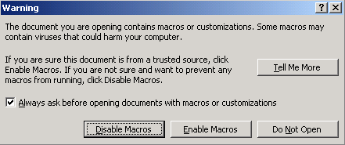
To allow the Biography Generator to run click the Enable Macros button and it should open. If you don't get the message and the Biography Generator won't open, try going to Tools / Options / General and unchecking "Macro virus protection". You may have to close and reopen any open documents but the Biography Generator should now open. When you have saved your biography remember to go back to Tools / Options / General and check "Macro virus protection".

In Microsoft Word 2000 or later:

If you get a message like above simply click the Enable Macros button. If no message appears at all and the Biography Generator won't open go to Tools / Macro / Security. You will probably find the Security Level set at High which prevents any document containing a macro from opening. If you select Medium, click OK and open the Biography Generator you should get a message like above where you can then click the Enable Macros button.

